**III Semester B. Tech - Computer and Communication Engineering**

**19CCE201 Microcontroller and Interfacing Techniques**

**Term Work**

**FLAME SENSOR INTERFACING WITH LPC2148**

**Prepared by:**

|  |  |  |
| --- | --- | --- |
| **S .NO** | **NAME** | **ROLL NO** |
| 01 | Prakalya | CB.EN.U4CCE21018 |
| 02 | Pranjali Yadav | CB.EN.U4CCE21047 |
| 03 | Pubesh Kumar K S | CB.EN.U4CCE21048 |
| 04 | Rithanya S | CB.EN.U4CCE21054 |

**Department of Electronics and Communication Engineering**

**Amrita School of Engineering, Coimbatore - 641112**

**2022 – 2023 (odd)**

**MOTIVATION**

Fire accidents are very dangerous and can spread fast if not detected. A small flame can cost collateral damage when it becomes uncontrollable. To ensure such incidents do not occur in any company or factory, a fire sensor is used. Here we are doing a flame sensor using LPC2148 ARM 7 TDMI.

**THEORY**

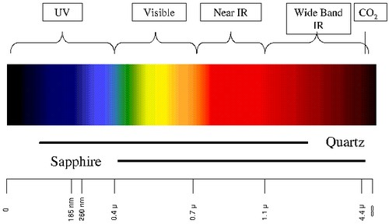

The flame sensor detects the presence of flame based on the infrared rays emitted by it. A flame sensor can detect fire or any other light source whose wavelength ranges from 760 nm to 1100 nm. It detects the presence of flame based on the infrared rays emitted by it. Inside this device are IR sensor, an LCD for indication, an operational amplifier circuit, and a potentiometer. The device is sensitive to flame so, whenever detects , turns on the LCD to show any indication.If detected , output is given to be 1 otherwise 0. The ARM checks the logic level on the output pin of the sensor and performs tasks as activating the LCD, sending an alert message “FLAME DETECTED”.The sensitivity of the flame sensor can be adjusted according to the requirements.

**DESIGN:**

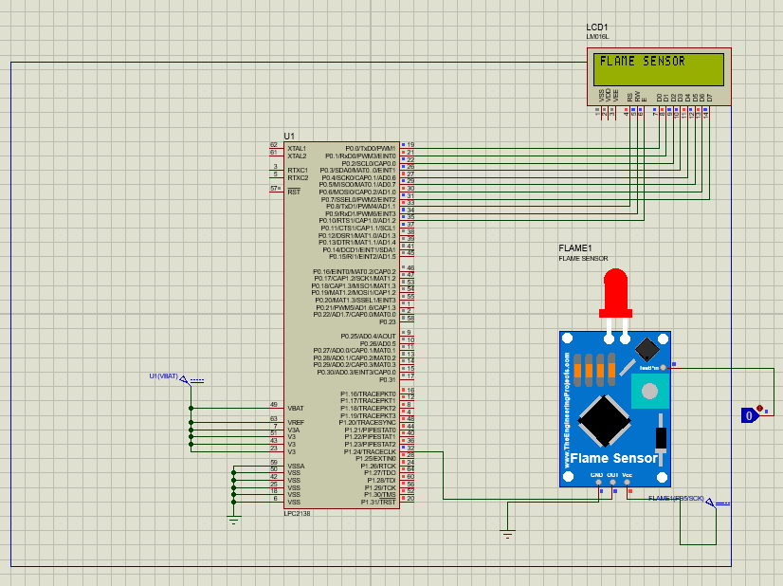

**CODE**

#include<lpc213x.h>

#define bit(x) (1<<x)

#define delay for(i=0;i<35000;i++);

#define FLAME (IO1PIN & (1<<24))

unsigned int i;

void lcd_int();

void dat(unsigned char);

void cmd(unsigned char);

void string(unsigned char *);

int main()

{

IO0DIR =0XFFF;

IO1DIR = 0x0;

lcd_int();

cmd(0x80);

string("FLAME SENSOR");

while(1) {

if(FLAME) {

string("Flame Detected");

}

delay;delay;

cmd(0x01);

}

}

void lcd_int()

{

cmd(0x38);

cmd(0x0c);

cmd(0x06);

cmd(0x01);

cmd(0x80);

}

void cmd(unsigned char a)

{

IO0PIN&=0x00;

IO0PIN|=(a<<0);

IO0CLR|=bit(8); //rs=0

IO0CLR|=bit(9); //rw=0

IO0SET|=bit(10); //en=1

delay;

IO0CLR|=bit(10); //en=0

}

void dat(unsigned char b)

{

IO0PIN&=0x00;

IO0PIN|=(b<<0);

IO0SET|=bit(8); //rs=1

IO0CLR|=bit(9); //rw=0

IO0SET|=bit(10); //en=1

delay;

IO0CLR|=bit(10); //en=0

}

void string(unsigned char *p)

{

while(*p!='\0') {

dat(*p++);

}

}

**RESULT**

The project is designed to catch the threshold wavelength of the IR (flame) and sense the danger to prevent further accidents. The monitoring and controlling of the flame is done using the code programmed in KEIL which is visualized and simulated using the PROTEUS application. On simulating, once the flame is detected, logic is passed as the output ; Otherwise logic 0. Hence, the alert is displayed by LCD.

**INFERENCE**

Today’s flame detectors make use of optical technology to stumble on flames. Flames are recognized to emit electromagnetic radiation with inside the infrared (IR), seen light, and ultraviolet (UV) wavelengths relying at the gasoline source. Since greater than 90% of the flame’s overall radiation is infrared, those detectors acquire sufficient radiation of pretty excessive depth and could perform with both very vulnerable or particularly warm flames.